Activities during 2024-25
- Visit to Hiramani Old Age Home
12 March (Holi celebrations)
15 volunteers visited the old-age home and interacted with the inmates for around 3 hours. Armed with gifts like snacks, Tulsi, frames of poem and painting, the volunteers prepared a short performance, sang bhajans and ended the evening with garba. A special word of thanks to Dr. Dhruv who sponsored the entire event.
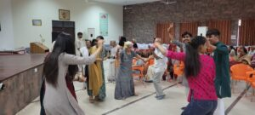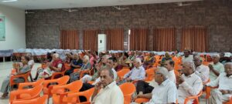

- Joy of Giving
8th January 2025
25th January 2025
In a unique two- phased program, RJTCC -CWDC volunteers spearheaded a collection drive for the needy.
On 8th 25 volunteers visited nearby slums to distribute woollens collected at the college. Greatly appreciated was the thoughtful gift wrapping and careful gifting of age-appropriate apparel.
On the 25th a similar drive saw volunteers distribute Masala Khichdi made with ingredients collected at the college.
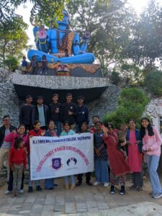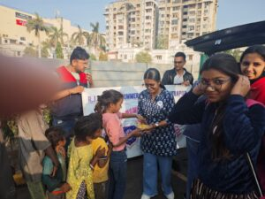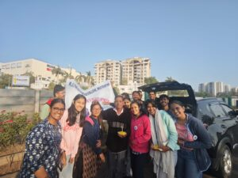
- Workshop on Garba:
23rd September 2024
40 pre-registered students participated in a one-day Garba workshop mentored by Ms Bindiya Vaghela, choreographer who runs Kridha classes.
The workshop was marked by gaiety and fervour.
- Workshop on Clay modelling
14th September 2024
24 students participated in a workshop on the Art of Clay modelling.
The workshop was mentored by Ms. Saloni Suthar, an alumnus of the college.
- Workshop on Preparing for Exams for Civil Services
9th August 2024
In collaboration with the library -RJTCC,a workshop was conducted on preparing for civil services All material, print and digital, that the college library offers towards this preparation was displayed in an exhibition.
Mentored by Mr.Bhavik Rao, the workshop had 40 participants.
- Orientation for freshers
8th August 2024
The freshers were introduced, and the core members felicitated in an orientation program where Dr T. U. Dhruv, the chief Guest spoke on the true meaning of Empowerment.
- Reel Rumble
July 2024
A competition aiming to acquaint students to the concept of video interviews was conducted.
15 reels were selected and the best 4 awarded.
- 30th July 2024
The same team of students who conducted the survey extended the activity to holding interactive sessions in schools of Vastrapur area.
They also distributed complimentary sanitary napkins to girl students of the schools.
- Survey on Awareness in Mensural Hygiene
June 2024
A team of 6 volunteers curated a questionnaire on Awareness of Mensural Hygiene. The survey targeting primary, secondary and college students was conducted over a fortnight.
Seminar on Mensural Hygiene.

