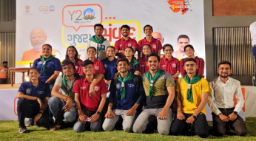
- 28/03/2023 :-Gujarat Talks/ Gujarat Samvad Program - Many volunteers of Team NSS RJTCC participated enthusiastically in the Y20 Gujarat Talks/Gujarat Samvad program held at Gujarat University.
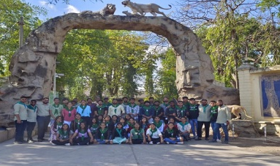
- 29/03/2023:-Environmental Study Tour Sasan Gir
Around 50 NSS volunteers of R J Tibrewal Commerce College, Ahmedabad participated in an environmental study tour at Sasan Gir.

- 05/04/2023 :- Electoral Roll Revision Program – 2023 was organized from 5th April to 23rd April 2023 under the guidance of The Chief Election Commission Gujarat State where 17 volunteers helped in the revision

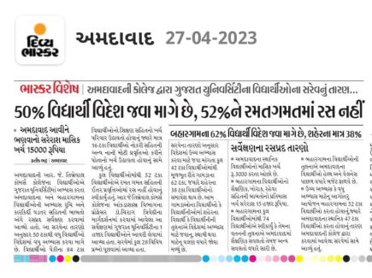
- 27/04/2023:- Statistical study of local and migrant students in Gujarat university - A survey was conducted by Nakul, Hina and Tanvi of Sem 6 of R.J. Tibrewal Commerce College . The survey conducted under guidance of college professors, covered all aspects of life style and career choices.

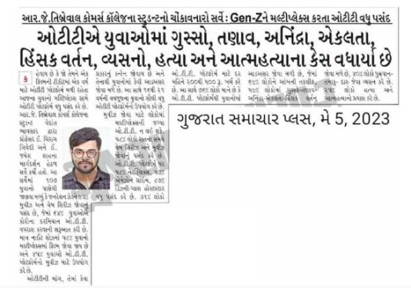
- 05/05/2023:- Survey on the Growing demand of OTT platforms against Multiplexes

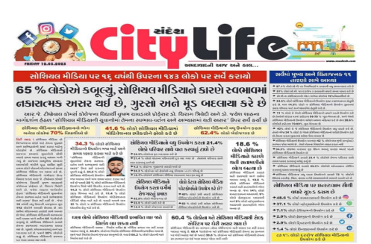
- 12/05/2023 : Survey on “Effects of Social Media among Youth , their behavior and academic success” - A survey was conducted by 35 students of R.J. Tibrewal Commerce College on the Effects of Social Media amongst Youth specially their behavior and Academic success. Social media is a platform for people around the world to discuss their issues and opinions. Interactive social networking sites like Twitter, whatsapp , Facebook and Instagram were some plstforms covered.
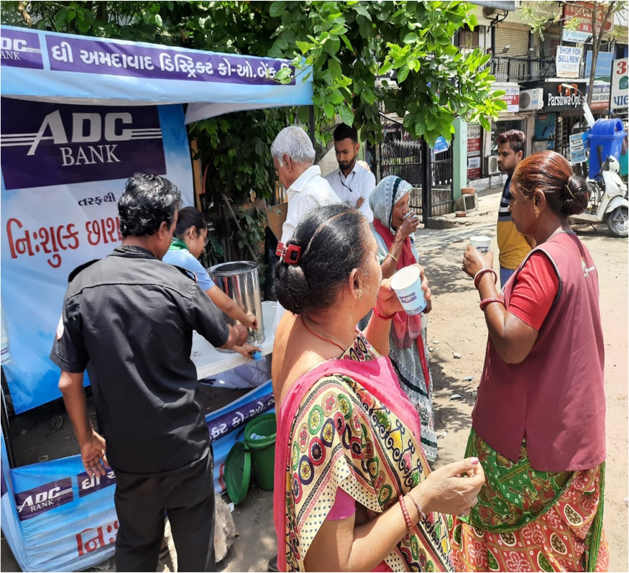
- 15/05/23 Chass Vitran: - 'Butter Milk Distribution Centers' were set up in various areas with the joint efforts of GSC Bank, Bank and Indian Red Cross Society, Gujarat State Branch here 15 volunteers managed the distribution.

- 31/05/2023: World No Tobacco Day - NSS RJTCC unit was invited to present a play at the Tagore Hall on Awareness against Addiction. The awareness program was organized by AMC and Chetana Foundation. The play 'VYASAN-MUKTI’ was well appreciated by office bearers and employees of AMC and general public.

- 21/06/2023:- International Yoga Day - The 9th International Yoga Day was celebrated by the NSS RJTCC Unit. A training camp was organized from 16th June to 21st June 2023.

- 26/06/2023 :- International Day Against Drug Abuse - June 26th was celebrated as International Day Against Drug Abuse and Illicit Trafficking . A play on "Nasha Mukti" was presented in the college campus by 24 volunteers of NSS RJTCC Unit with the aim of educating the youth.
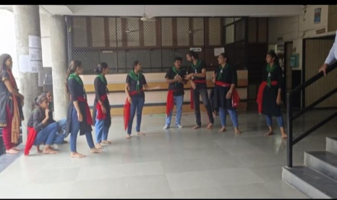
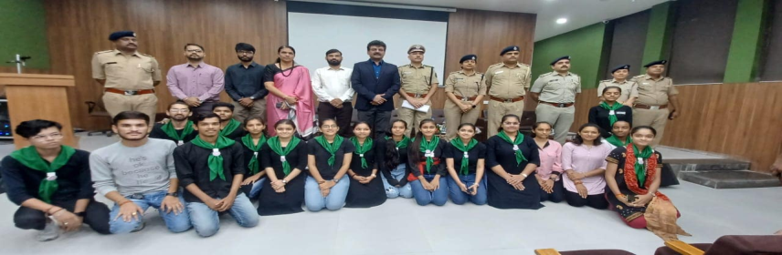

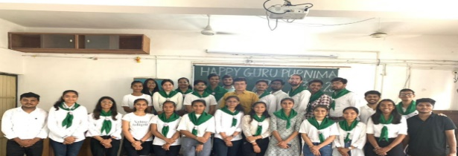
- 03/07/2023 :- Guru-purnima Celebration - NSS RJTCC Unit celebrated Guru-purnima traditionally in the college campus. The students of the college performed gurupujan with sweets. The program concluded with recitation of Guru strotra and Guru Bhajans.

